**EXPERIMENT 8 – PANDAS  
SCREENSHOT OF CODE**

REYES, John Emmanuel A. Nov.25,2019

2ECE-B

PROBLEM 1:

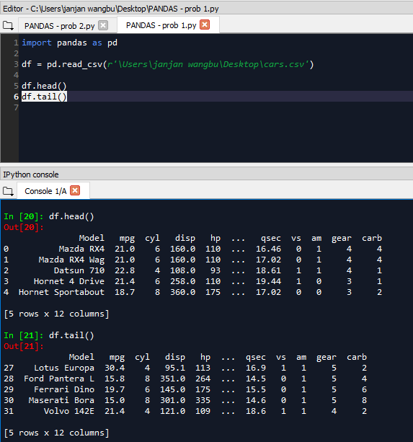

PROBLEM 2:

